**K4 Series**

**RF Module Specification**

**Document modification history**

|  |  |  |
| --- | --- | --- |
| **Version** | **Description** | **Date** |
| V1.0 | Create | 2015-5-1 |
| V1.1 | Optimizing Content | 2016-6-10 |
| V1.2 | Revise | 2017-5-17 |

Catalogue

**Catalogue**

Chapter I Product overview 3

1.1 Summary 3

1.2 characteristic 3

1.3 Appearance and interface diagram 4

Chapter II List of basic functions 6

Chapter III PCB size and interface layout 8

3.1 Interface parameter description 8

Chapter IV Magnetic Lock Wiring Standard 11

**Chapter I Product overview**

## Summary

The M2 module is a 13.56MHZ high-frequency read-write module. The module has its own CPU control, which does not require secondary programming. The complete serial port transceiver can be seamlessly connected with any system without loading any driver. The integrated on-board RF antenna has more stable performance, and is very suitable for charging piles, self-service sales, and advertising machines.

## Characteristic

* + - 1、Small size access controller, no larger than 35X35MM, convenient for integrated use of various devices.
    - 2、The controller has 1 channel of access control IO output, 1 channel of button, 1 channel of door magnetic feedback and 1 channel of human body induction.
    - 3、The controller has mass storage inside, and the storage permissions are no less than 1000.
    - 4、The controller has 13.56MHZ high frequency read-write function.
    - 5、Support mode switching, read-only or read-write mode setting, and three output formats can be switched in read-only mode.

## Appearance and interface diagram

Front/Back：

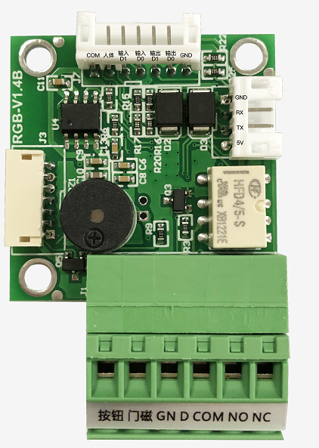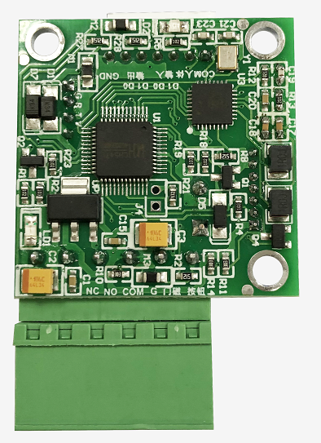

**Chapter II List of basic functions**

|  |  |
| --- | --- |
| **Main technical parameters** | |
| Support Agreement | ISO14443A |
| Support  Card | Mifare（1K/4K）；NXP S50,NXP S70，Fudan Microenterprise F08，Ultralight |
| Operating System | Windows98、XP、Win7、8、ME、2003、VISTA、LIUNX、UNIX、Android |
| Card Reading Distance | 00~60mm |
| Card Reading Time | ＜100ms |
| Communication Rate | 9600 |
| RF Antenna | Integrated with PCB |
| Communication Interface | Uart TTL |
| Working Voltage | Standard 5V |
| Operating Current | 60mA |
| Working Frequency | 13.56MHZ |
| Work Environment | Temperature（-20℃~85℃）  Humidity（5%~95%） |
| Indicator Light | LED |
| Built In Horn | Controllable Buzzer |
| Other Interfaces | Weigand Output（D0 D1）、Magnetic Door、  Human Body Sensing、 Button |
| Product Size | 35mm×35mm； Thickness 1.2mm |

**Chapter III PCB size and interface layout**

* 1. **Interface parameter description**
* **Power input interface**

The 5V DC power supply is adopted, and only **the computer or development board** is allowed to supply power to the board subsystem. In the case of no external empty load, the 9V DC power supply needs to support a minimum current of 100mA.

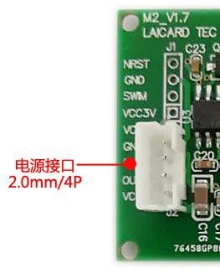

The interface of the power socket is defined as follows, which can be powered by the main control board. The specification of the seat is 4PIN 2.0mm spacing.

|  |  |  |  |
| --- | --- | --- | --- |
| **The serial number** | **Definition** | **Attribute** | **Description** |
| 1 | GND | Ground Wire | Ground Wire |
| 2 | --- | --- | --- |
| 3 | --- | --- | --- |
| 4 | VCC | Power Supply | 5V Input |

The standard configuration is 5V power supply. If 3.3V power supply is to be used, the power regulator chip needs to be removed. Two 0R resistors, R8 and R11, need to be connected in series. If 9V power supply is to be used, just move the R8 resistor 0R to the R11 position (The function is that the buzzer power supply voltage cannot be greater than 5V).

* **Serial port communication socket port**

Only 4 wires(VCC、TXD、RXD、GND) are needed to connect the corresponding motherboard to complete serial port communication. Pay attention to the serial port output voltage of the motherboard, select the corresponding matching level signal, and pay special attention to whether the motherboard is a 232 serial port or a TTL serial port.

**Points For Attention:**

1.The serial port does not communicate. Check whether the level does not match. The TTL is connected to 232.

2.Whether the TX and RX connections are correct.



|  |  |  |  |
| --- | --- | --- | --- |
| **The serial number** | **Definition** | **Attribute** | **Description** |
| 1 | GND | Ground Wire | Ground Wire |
| 2 | IN | Input | Connected to MCU-TX |
| 3 | OUT | Output | Connected to MCU-RX |
| 4 | VCC | Power Supply | 5V Input |

**Chapter IV Magnetic Lock Wiring Standard**

Magnetic lock V + Connected to power NCMagnetic lock V - Connected to power GNDAccess control NO is connected to power PUSHAccess control COM is connected to power GND